**Lab-01 : Install and Configure Prerequisites**

***Please follow lab guide as well as “Screen Shot”***

##### **Step 1 : Update your OS**

# apt-get update

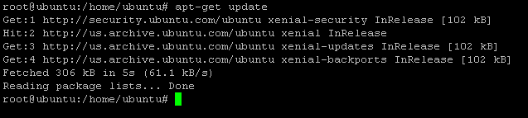

**Step 2a :** **Enable openstack repositories**

# apt install software-properties-common

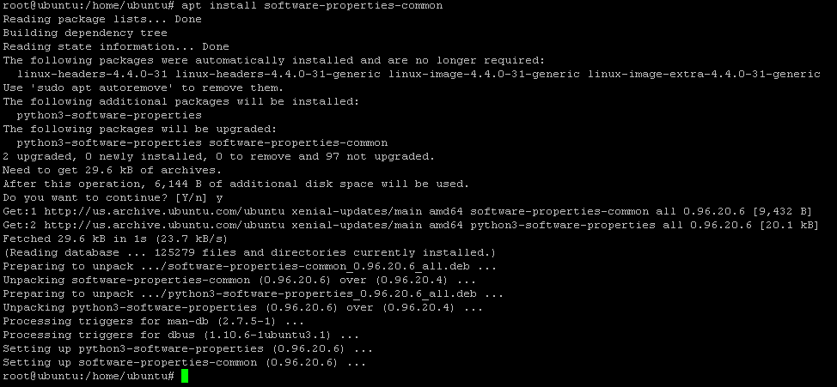

**Step 2b:** **Add Newton repositories**

# add-apt-repository cloud-archive:queens

##### 

**ENTER**

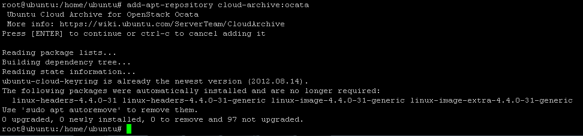

##### **Step 3: Update and upgrade**

# apt-get update && apt-get dist-upgrade

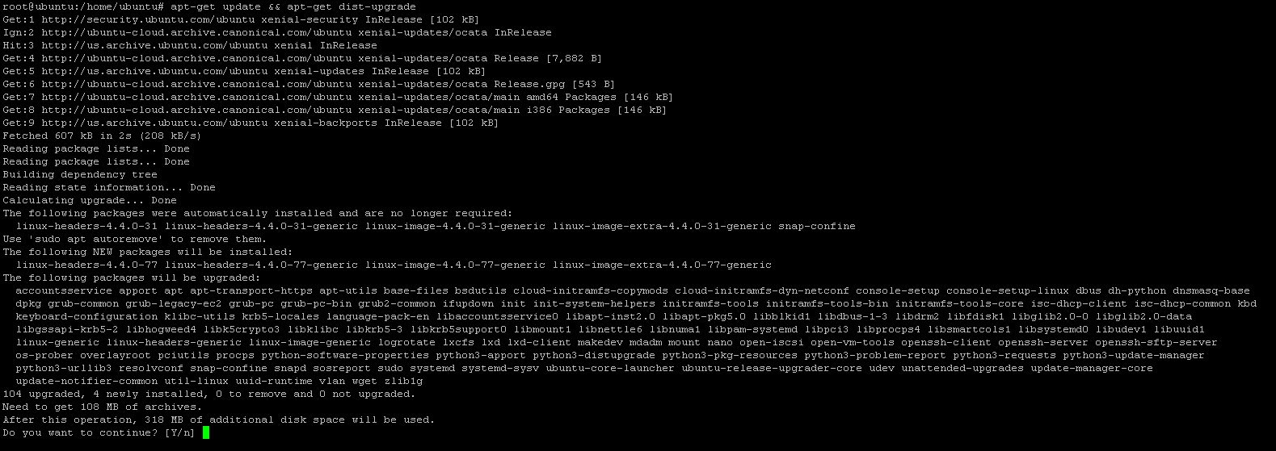

**Step 4: Install and Configure Open vSwitch**

# apt-get install -y openvswitch-switch

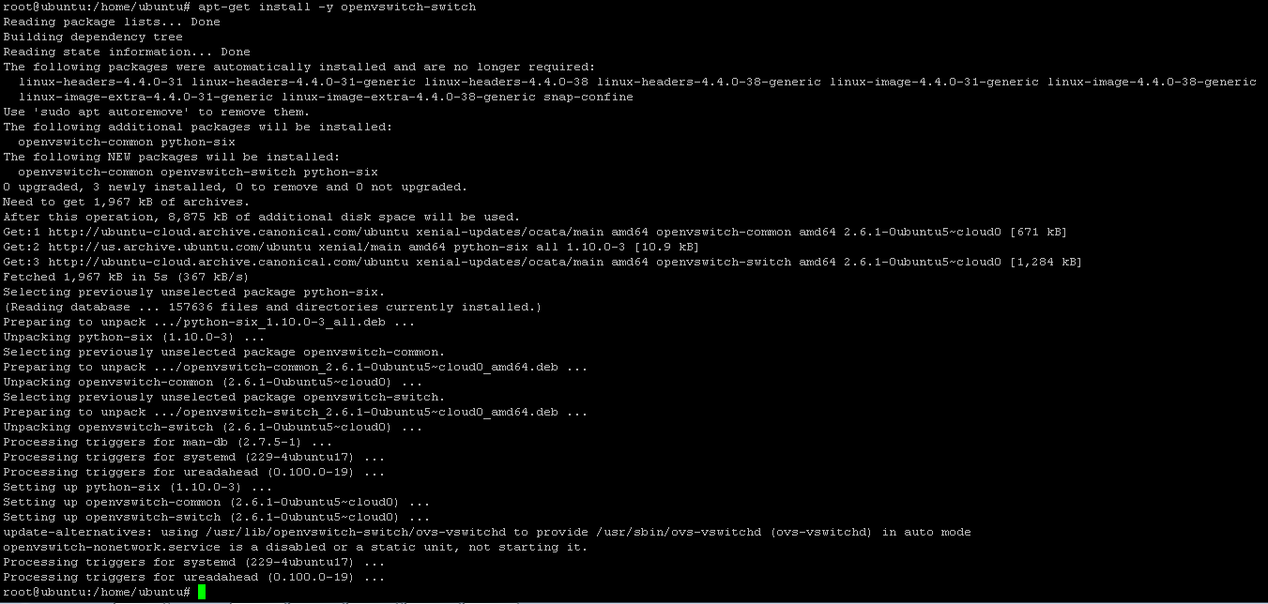

**Step 5: Create External Bridge by name br-ex**

# ovs-vsctl add-br br-ex



**Step 6 : Edit Your network interface files with copy below details and change your IP address as per your environment**

# vim /etc/network/interfaces

auto eth1

iface eth1 inet manual

up ifconfig $IFACE 0.0.0.0 up

upip link set $IFACE promisc on

downip link set $IFACE promisc off

down ifconfig $IFACE down

auto br-ex

iface br-ex inet static

address 192.168.0.59

netmask 255.255.255.0

network 192.168.0.1

broadcast 192.168.0.255

gateway 192.168.0.1

dns-nameservers 8.8.8.8

#OpenStack management network (used by Openstack services like Nova,etc)

auto eth0

iface eth0 inet static

address 192.168.0.60

netmask 255.255.255.0

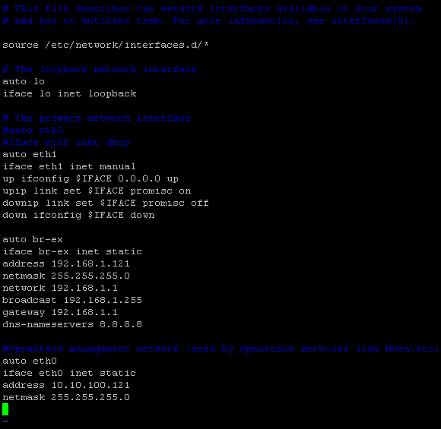

**Step 7: Add the interface to** **the br-ex bridge you created**

# ovs-vsctl add-port br-ex eth1



**Step 8: Configure kernel networking parameters for packet forwarding**

# vim /etc/sysctl.conf

net.ipv4.ip_forward=1

net.ipv4.conf.all.rp_filter=0

net.ipv4.conf.default.rp_filter=0

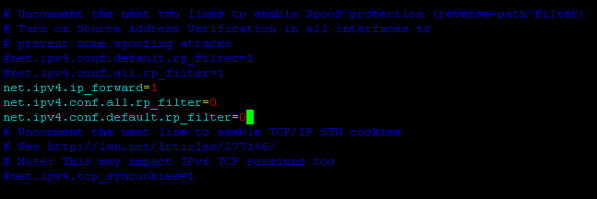

**Step 9: Reload kernel parameter**

# sysctl -p

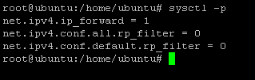

**Step 10: Restart the Server**

# init 6

**Step 11: Install MariaDB and RabbitMQ**

# apt install mariadb-server python-pymysql

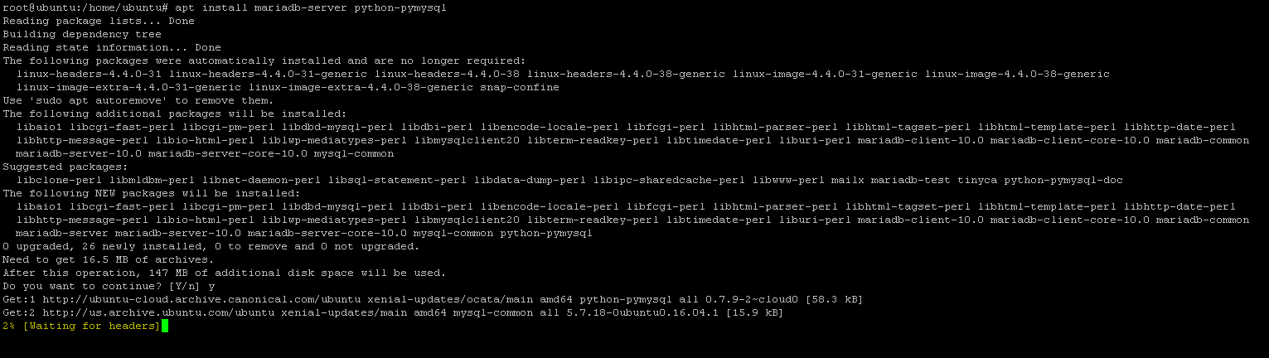

**Step 12: Configure MariaDB to accept all incoming requests**

# vim /etc/mysql/mariadb.conf.d/99-openstack.cnf

[mysqld]

bind-address = 0.0.0.0

default-storage-engine = innodb

innodb_file_per_table = on

max_connections = 4096

collation-server = utf8_general_ci

character-set-server = utf8

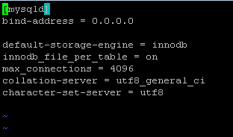

**Step 13: restart the mysql service**

# service mysql restart



**Step 14: Secure the database service**

# mysql_secure_installation

**// Set Root Password as *root1234***

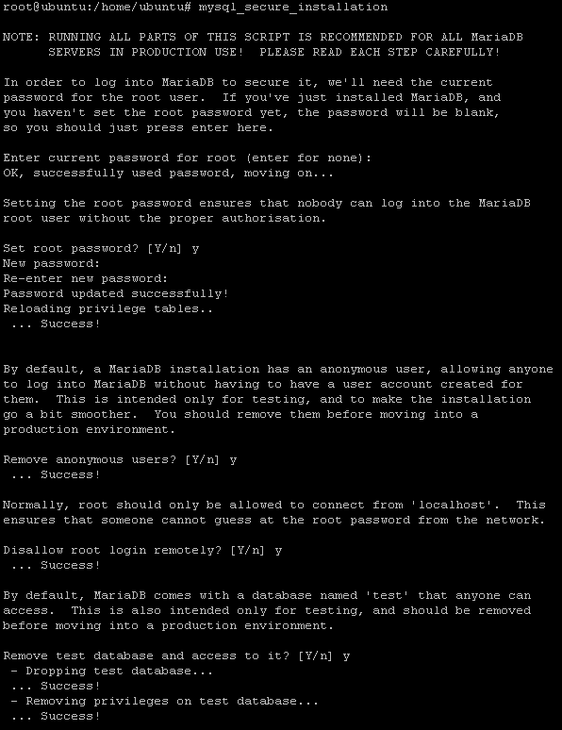

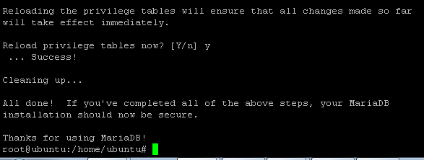

**Step 15 : Install RabbitMQ Server**

# apt-get install -y rabbitmq-server

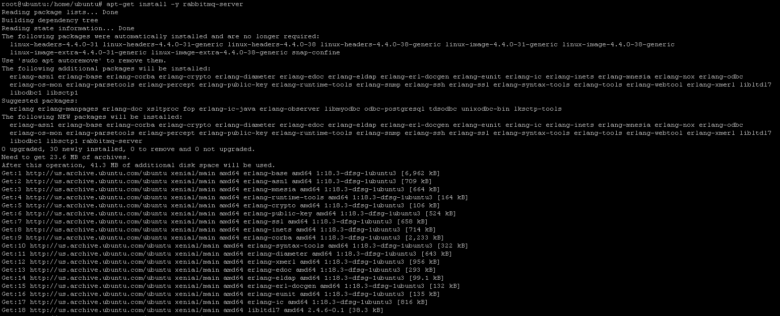

**Step 16 : Change user name and password of rabbitmq**

# rabbitmqctl add_user openstack rabbit

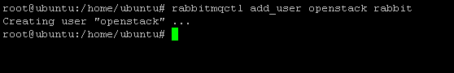

**Step 17: Set the permission**

# rabbitmqctl set_permissions openstack ".*" ".*" ".*"

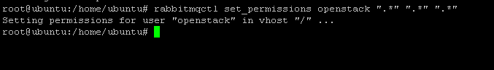

**Step 18: Installation of memcache**

# apt-get install memcached python-memcache

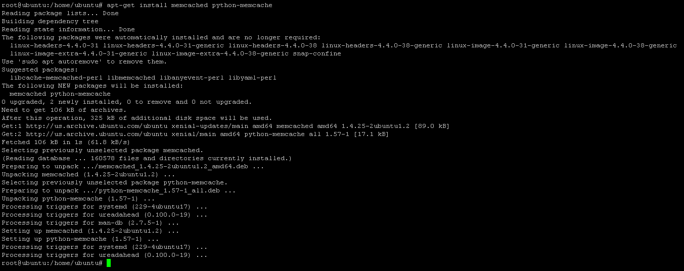

**Step 19: Configuration of memache file**

# vim /etc/memcached.conf

-l 0.0.0.0

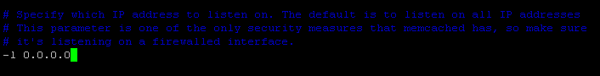

**Step 20: Restart the Memcached service**

# service memcached restart

